Kubernetes 04
- Deploy an application using a Deployment with 3 replicas and a rolling update strategy.
- Deployement.yml
- 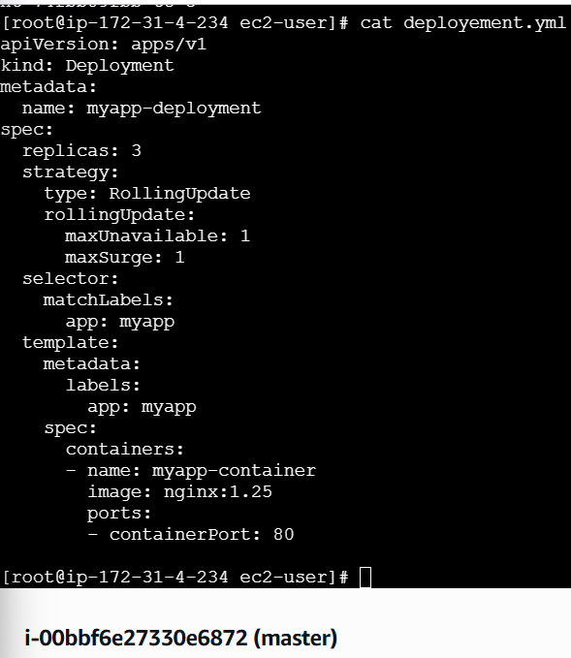
- Now , deploy the app
- kubectl apply -f deployment.yml
- kubectl get deployments
- kubectl get pods
- kubectl get nodes
- 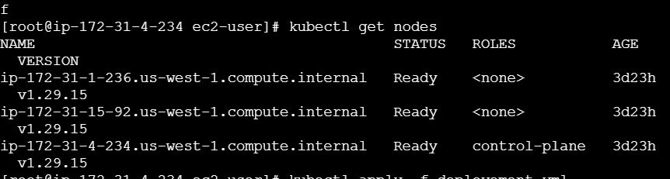
- kubectl get deployments
- 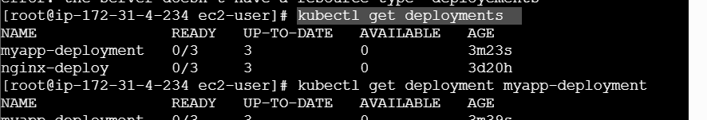
- kubectl get deployment myapp-deployment
- 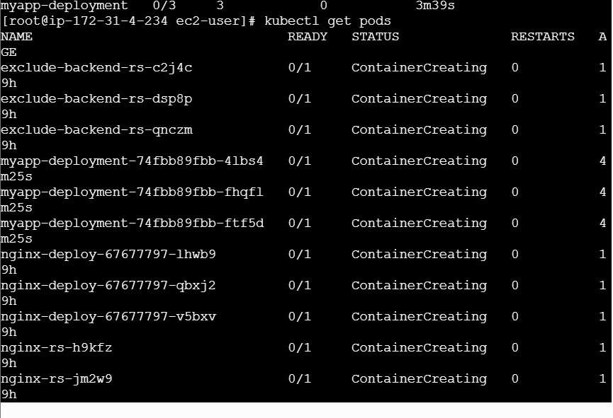
- Configure a Deployment with a Recreate strategy and observe the downtime.
- Create file
- Nginx deployement
- apiVersion: apps/v1
- kind: Deployment
- metadata:
- name: nginx-deploy
- spec:
- replicas: 3
- selector:
- matchLabels:
- app: nginx
- template:
- metadata:
- labels:
- app: nginx
- spec:
- containers:
- - name: nginx
- image: nginx
- ports:
- - containerPort: 80
- Check pods
- 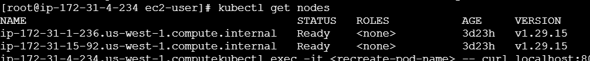
- Deploy now
- kubectl apply -f nginx-deploy.yml
- kubectl get pods
- now, nodeport service file
- apiVersion: v1
- kind: Service
- metadata:
- name: nginx-service
- spec:
- type: NodePort
- selector:
- app: nginx
- ports:
- - port: 80
- targetPort: 80
- 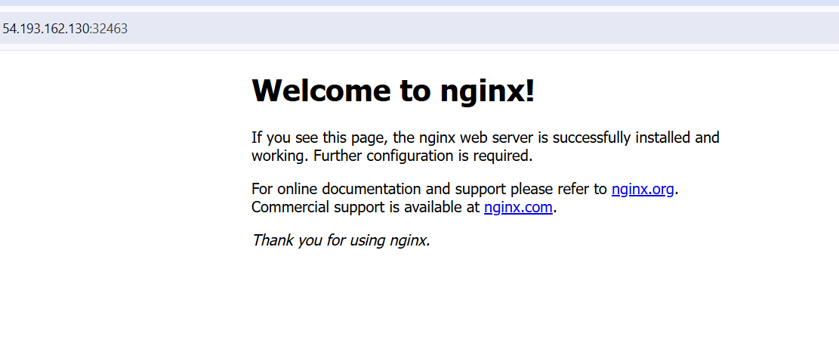
3 . Update an existing Deployment and perform a rollback to the previous version.
- Check current deployements
- kubectl get deployments
- 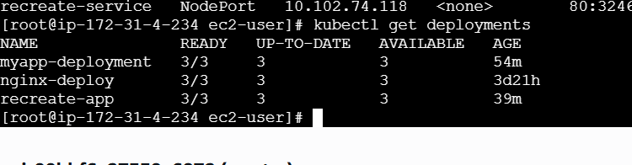
- Check image version
- kubectl describe deployment nginx-deploy | grep Image
- 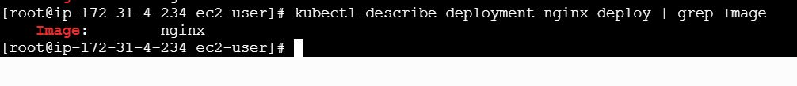now increase the version
- kubectl set image deployment/nginx-deploy nginx=nginx:1.26
- 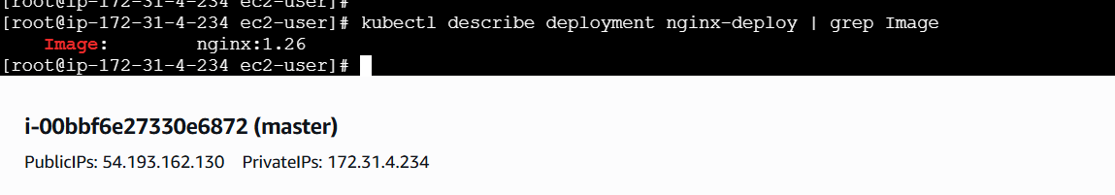
- Check again
- kubectl describe deployment nginx-deploy | grep Image
- version increased
- 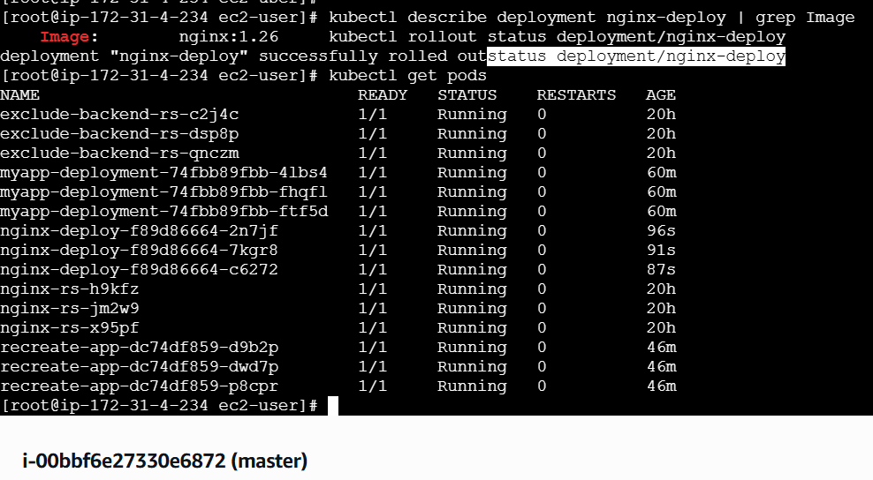
- Show the status of version
- kubectl rollout status deployment/nginx-deploy
- its 1.26
- Now rollback to pervioous version
- This is the command
- kubectl rollout undo deployment/nginx-deploy

4. Modify a Deployment to add resource requests and limits for CPU and memory.
- Check deployements
- kubectl get deployments
- now create a yaml file
- vi nginx-resource.yaml
- yaml file
- apiVersion: apps/v1
- kind: Deployment
- metadata:
- name: nginx-deploy
- spec:
- replicas: 3
- selector:
- matchLabels:
- app: nginx-lb
- template:
- metadata:
- labels:
- app: nginx-lb
- spec:
- containers:
- - name: nginx
- image: nginx:1.26
- ports:
- - containerPort: 80
- resources:
- requests:
- cpu: "100m"
- memory: "128Mi"
- limits:
- cpu: "500m"
- memory: "256Mi"
- 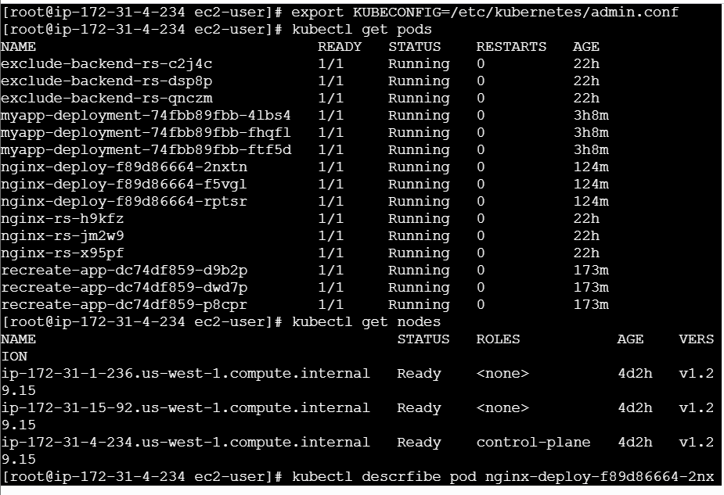
- Apply the deployment
- kubectl apply -f nginx-resources.yaml
- rollout
- kubectl rollout status deployment nginx-deploy
- verify resources
- kubectl describe pod -l app=nginx-lb
- 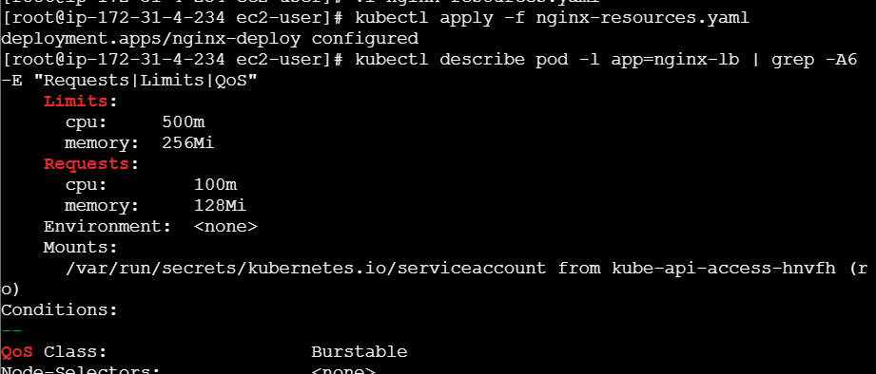

5 . Create a Deployment with MaxSurge and MaxUnavailable configurations.
- Vi nginx-rolling.yaml
- apiVersion: apps/v1
- kind: Deployment
- metadata:
- name: nginx-rolling
- spec:
- replicas: 4
- strategy:
- type: RollingUpdate
- rollingUpdate:
- maxSurge: 25%
- maxUnavailable: 25%
- selector:
- matchLabels:
- app: nginx-rolling
- template:
- metadata:
- labels:
- app: nginx-rolling
- spec:
- containers:
- - name: nginx
- image: nginx:1.26
- ports:
- - containerPort: 80
- Apply deployement
- Kubectl apply -f nginx-rolling.yaml
- Verify the deoployment
- Kubectl get deployment nginx-rolling
- 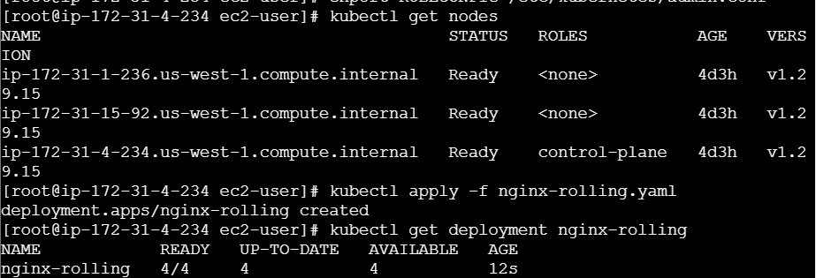
- Kubectl get deployment nginx-rolling | grep -A5 rollingupdate
- 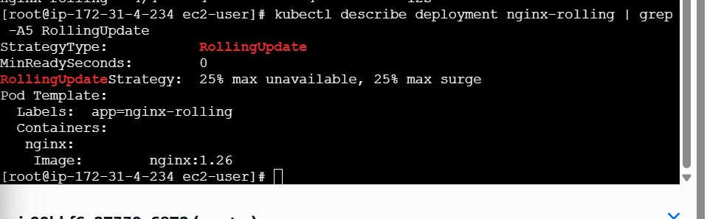
6. Set up a Deployment with a custom revision history limit.
Deployment
└─ spec
├─ replicas
├─ revisionHistoryLimit
├─ strategy
└─ template
- Vi nginx-revision.yaml
- apiVersion: apps/v1
- kind: Deployment
- metadata:
- name: nginx-revision
- spec:
- replicas: 3

- revisionHistoryLimit: 2 # 👈 CUSTOM REVISION LIMIT

- strategy:
- type: RollingUpdate
- rollingUpdate:
- maxSurge: 25%
- maxUnavailable: 25%

- selector:
- matchLabels:
- app: nginx-revision

- template:
- metadata:
- labels:
- app: nginx-revision
- spec:
- containers:
- - name: nginx
- image: nginx:1.26
- ports:
- - containerPort: 80
- Deploy it
- kubectl apply -f nginx-revision.yaml
- now revisionhistroylimit
- kubectl get deployment nginx-revision -o yaml | grep revisionHistoryLimit
- 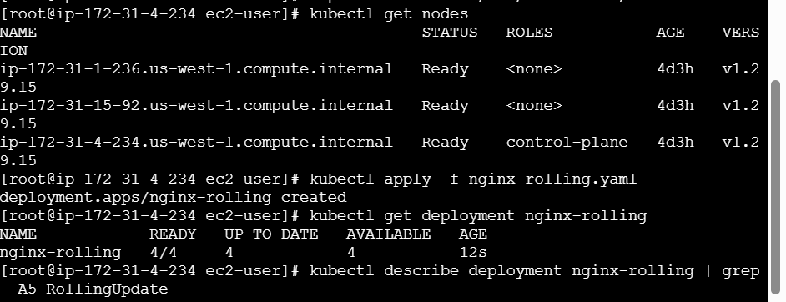
- Revisionlimitstroylimit: 2
- 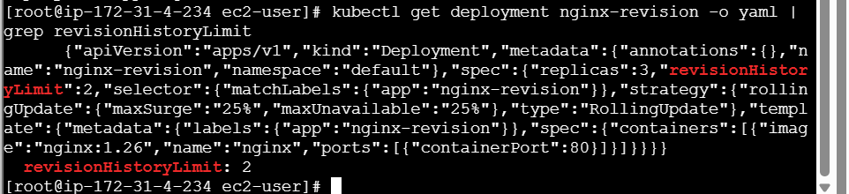
7. Pause a Deployment during an update and then resume it.
- Pause = stop rollout
- Resume = start rollout
- Pause the deployment
- kubectl rollout pause deployment nginx-deploy
- 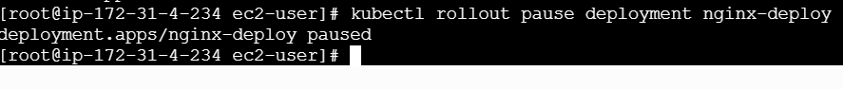
- Paused
- 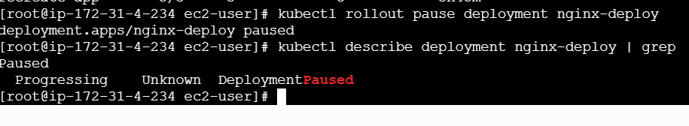
- Change image
- kubectl set image deployment/nginx-deploy nginx=nginx:1.25
- 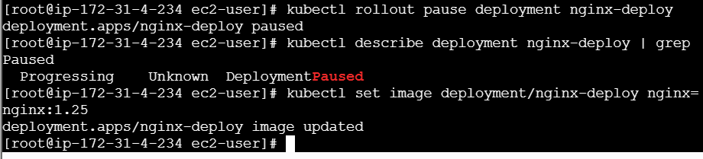
- kubectl rollout resume deployment nginx-deploy
- resumed now
- 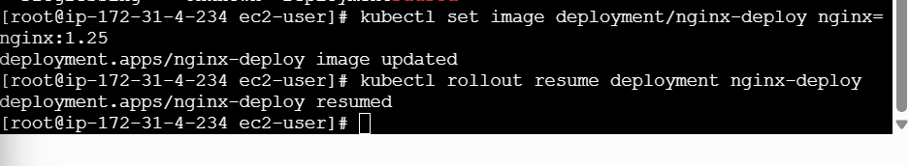

8. Create a pod using resource requests for memory and CPU and observe how the scheduler assigns it to a node.
- • requests → used for scheduling
- • limits → used for runtime enforcement
- Resource request
- vi pod-requests.yaml
- yaml file
- apiVersion: v1
- kind: Pod
- metadata:
- name: resource-demo-pod
- spec:
- containers:
- - name: nginx
- image: nginx
- resources:
- requests:
- cpu: "200m"
- memory: "256Mi"
- limits:
- cpu: "500m"
- memory: "512Mi"
- 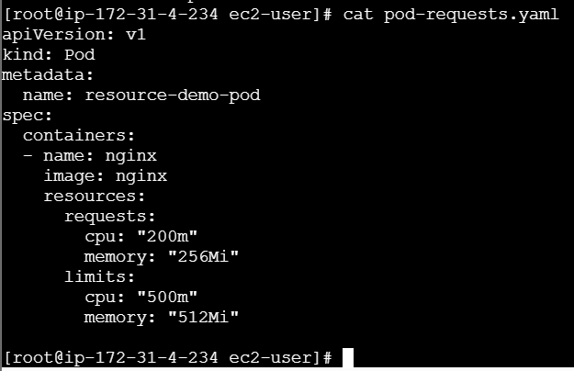
- Deploy the pod
- 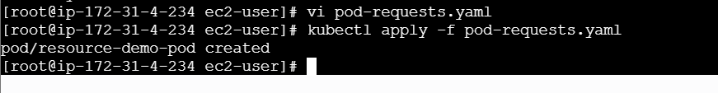
- Check which node scheduler picked
- Kubectl get pod resource-demo-pod -o wide
- 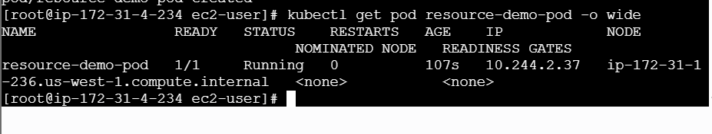
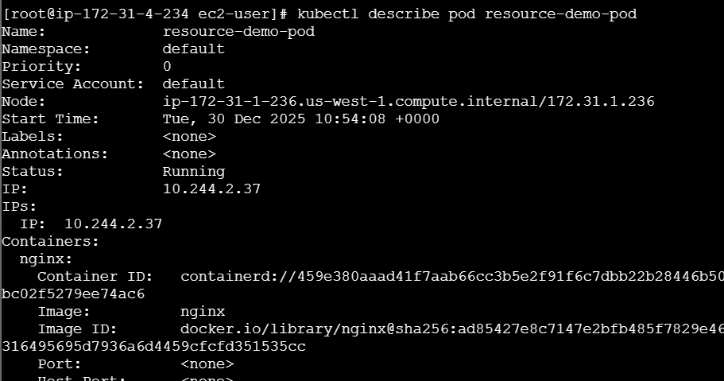

- Deploy now
- kubectl apply -f service.yml
- kubectl get svc
- add in bound rule in aws
- TCP 32463 → 0.0.0.0/0
- Check running
- kubectl get pods -l app=recreate-app
- 